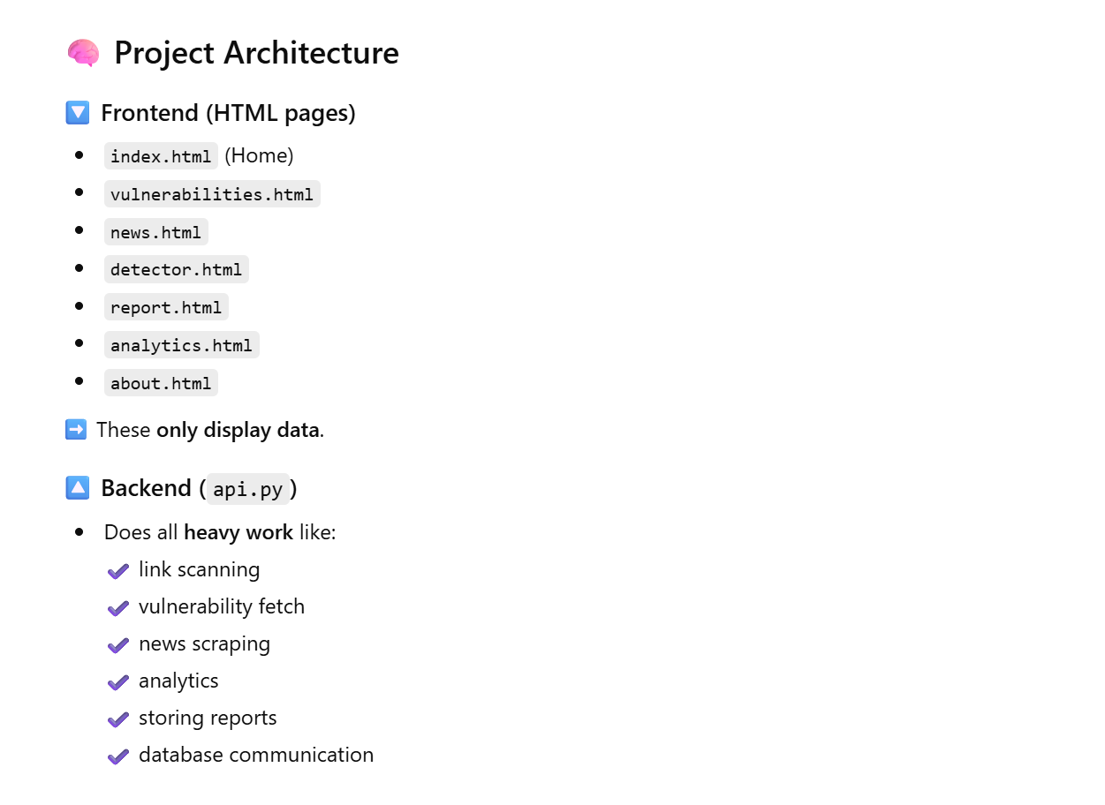
To run server:
uvicorn backend.api:app --reload
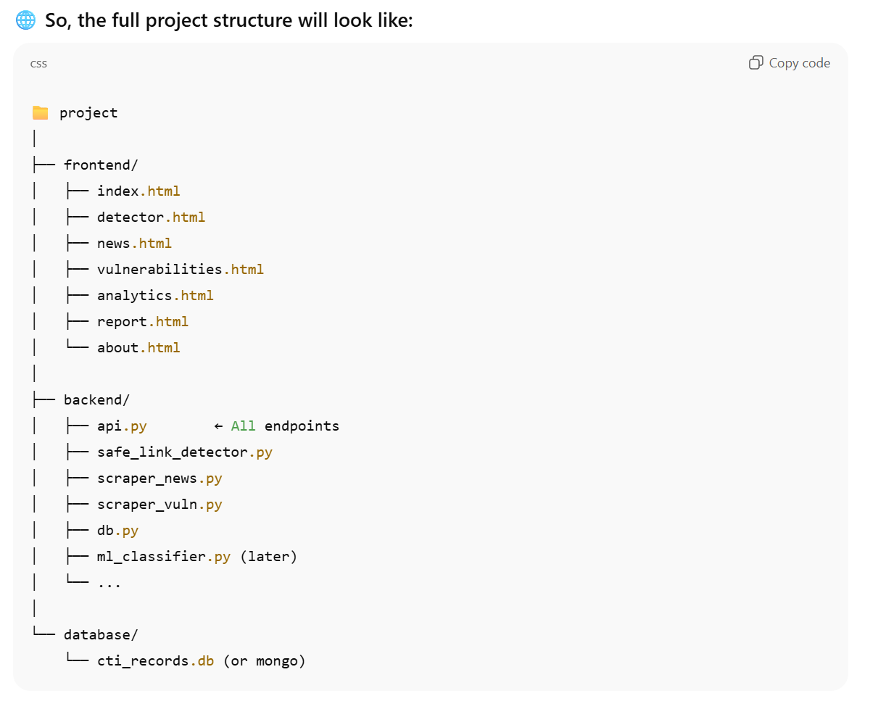

SafeLink Detector
API used:
Feature | Source | Free/Paid
Malware / Phishing reputation | Google Safe Browsing | Free
Known phishing | PhishTank | Free
Malware host URLs | URLHaus | Free
Domain age + registrar | WHOIS | Free
Server IP, location, ISP | IP-API | Free
Risk Pattern Detector | Local Heuristics | Free

Test run example links:
Suspicious
- https://bit.ly/paytm-free-wallet-update
- http://sbi-secure-login-update.xyz/

Safe
- https://www.reva.edu.in/

